**MySQL install**

**Purpose**

MySQL database 8.x is a pre-requisite for deploying an Aggregator or Aggregator-collector. This database houses all of the indexed data collected from your environment.

**Usage**

**Install requirements**

* Supported OS – Windows and Linux
* MySQL 8.x download – refer to [MySQL official documentation portal](https://dev.mysql.com/doc/refman/8.0/en/installing.html) for installation guidelines

**Windows install process**

* Download the MySQL server 8.x installer directly from [here](https://dev.mysql.com/get/Downloads/MySQLInstaller/mysql-installer-community-8.0.23.0.msi). The msi installer package is preferred as it makes installation straightforward. Once download is complete, launch the installer to get started.

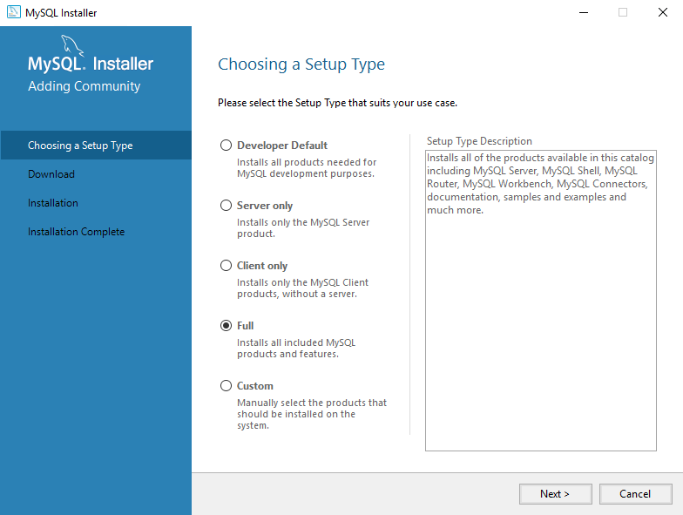Setup type Full

* To make sure we cover all the needed dependencies select the **Full**setup type. Click **Next** to continue once the selection is made.

Ein Bild, das Text enthält.
Check Requirements

* The installer will automatically check for requirements, the missing requirements can be ignored for our purposes as we will not need these for the subsequent Aparavi component installs. Clicking **Next** to proceed will result in a popup warning, click **Yes** to accept the warning and proceed.

Ein Bild, das Text enthält.
Warning

* The next step is the actual installation, you can review all the products that will be installed and select **Execute** to begin the installation process.

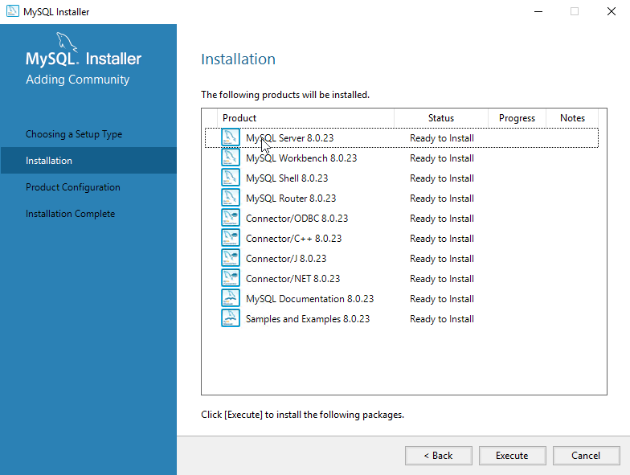Ready to install

* The MySQL installer will begin installing the products one by one, once completed, verify all products are successfully installed and click **Next** to move on.

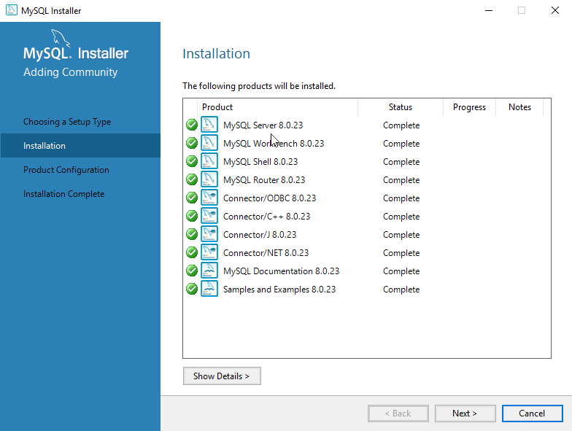Installation complete

* Now that the installation step is complete, you will need to configure the MySQL Server installation. Click **Next** to proceed to the configuration step.

Ein Bild, das Text enthält.
Aggregator online

* The next step is to configure the computer type and networking. For **Config Type**, select the type of server configuration, for our purposes select **Server Computer**. Unless there is a requirement to change the Port or other settings due to your environmental needs, the rest of the settings can be left at default. Click **Next** to proceed.

Ein Bild, das Text enthält.
Type and Networking

* The next step will be to select an authentication method for accessing the MySQL database, select **Use Legacy Authentication Method** and click **Next** to proceed.

Ein Bild, das Text enthält.
Authentication Method

* Now you will need to provide a password for the root access account and if desired, an additional user account can be created as well. Once completed, click **Next** to continue.

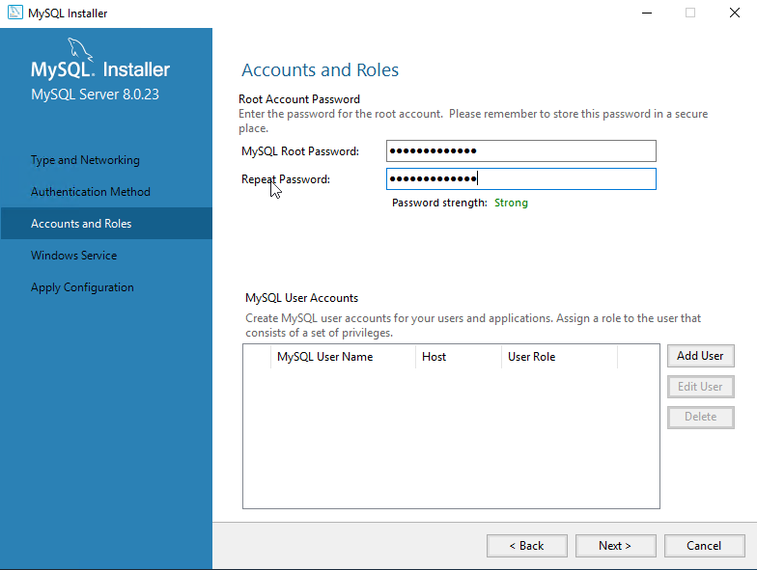Accounts and Roles

* Almost complete, unless there is a need to change any of the Windows service settings, accept the defaults and click **Next** to move onto the final step.

Ein Bild, das Text enthält.
Windows Service

* The final step is to apply the configuration settings, click Execute to begin the configuration process. Once the configuration is complete, you will see all nice green checkmarks and can click Finish.

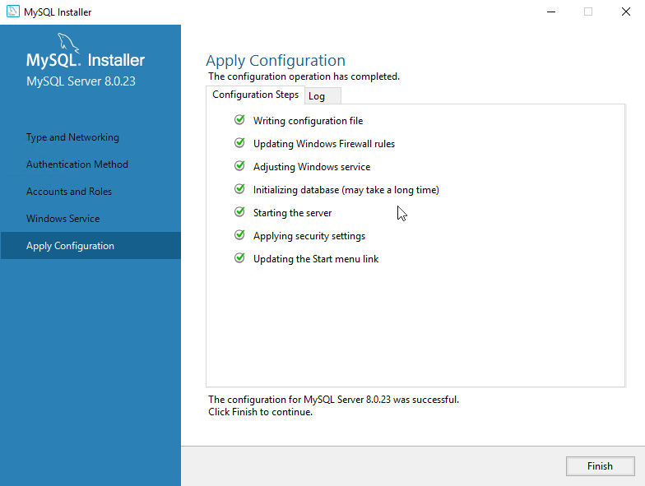Apply Configuration

* Now that the server configuration is complete, the installer will return you to the remaining product configurations. There is not a need to configure them for the Aparavi installations to follow, click Cancel. A confirmation box popup to confirm you wish to cancel, select Yes to exit the installer.

Ein Bild, das Text enthält.
Exit installer

* Now that MySQL server has been installed, verify that you can connect to the new database by launching MySQL Workbench.

Ein Bild, das Text, Screenshot, Elektronik, Anzeige enthält.
Start MySQL Workbench

* The MySQL Workbench application will launch and in the lower left-hand corner will be the database instance we configured in the previous steps. Select the instance by clicking on the box, you will need to provide the root user password to connect.

Ein Bild, das Text enthält.
MySQL Workbench

* If you are able to connect to the local instance, your installation and configuration of MySQL is now complete.

Ein Bild, das Text enthält.
Successfully connected

**Install differences for Linux**

* The installation steps outlined above were performed in a Windows operating system. For Linux, ensure that you are installing MySQL 8.x. For example: Ubuntu 18.x does not install MySQL 8.x by default instead it looks for MySQL 5.x. Make sure your repository is updated with the correct version or obtain an updated URL with the correct dpkg version.
* The installation must be secure – you may want to create a new user with secure password access to the database.

Refer to the MySQL documentation for any related installation questions or issues: <https://dev.mysql.com/doc/>